Курсов проект бази данни

**Музей**

Изготвили:

Тина Томова - 62594

Мария Марковска - 62568

Виктор Боев - 62564

Дейвид Каменов - 62585

**Разпределение на работата по проекта:**

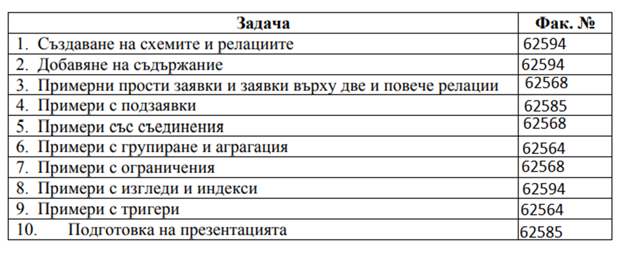

**Схема на базата от данни:**

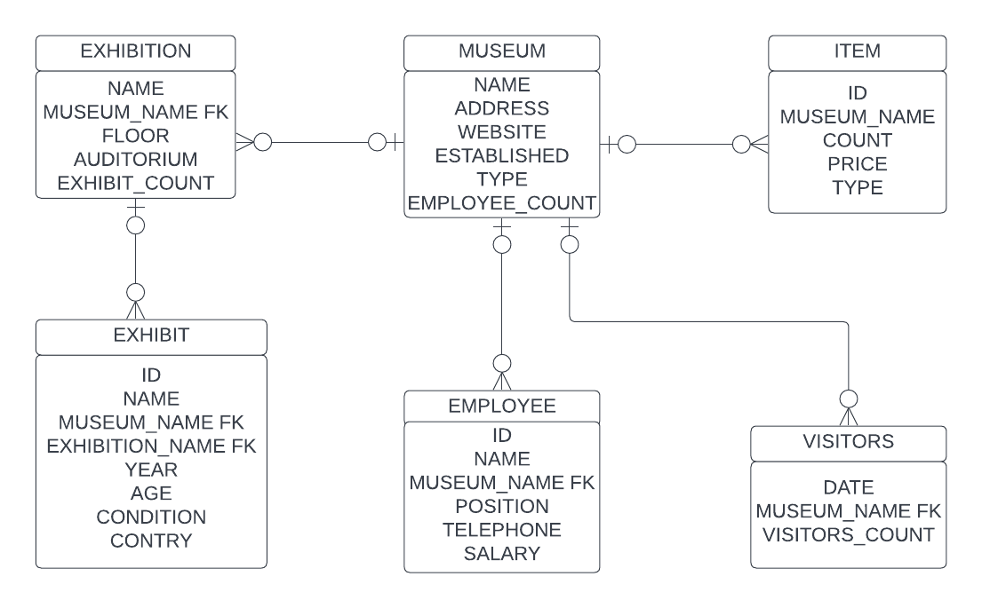

**Описание на базата от данни:**

Таблица MUSEUM

NAME - име, първичен ключ

ADDRESS - адрес

WEBSITE - уебсайт

ESTABLISHED - година на основаване

TYPE - вид

EMPLOYEE_COUNT - брой на персонала

Таблица EXHIBITION - NAME и MUSEUM_NAME образуват първичен ключ

NAME - име

MUSEUM_NAME - име на музея, външен ключ към NAME.MUSEUM

FLOOR - етаж

AUDITORIUM - зала

EXHIBIT_COUNT - брой на експонатите

Таблица EXHIBIT

ID - идентификационен номер, първичен ключ

NAME - име

MUSEUM_NAME - име на музея, външен ключ към NAME.MUSEUM

EXHIBITION_NAME - име на изложбата, външен ключ към NAME.EXHIBITION

YEAR - датира от

AGE - епоха ('ВС'-преди христа, 'АС'-след христа)

CONDITION - състояние (от 1 до 5; 1-много добро, 5-много лошо)

COUNTRY - държава

Таблица EMPLOYEE

ID - идентификационен номер, първичен ключ

NAME - име

MUSEUM_NAME - име на музея, външен ключ към NAME.MUSEUM

POSITION - длъжност

TELEPHONE - телефонен номер

SALARY - месечна заплата

Таблицата VISITORS - DATE и MUSEUM_NAME образуват първичен ключ

DATE - месец и година

MUSEUM_NAME - име на музея, външен ключ към NAME.MUSEUM

VISITORS_COUNT - брой на посетителите за месеца

Таблицата ITEM

ID - идентификационен номер, първичен ключ

MUSEUM_NAME - име на музея, външен ключ към NAME.MUSEUM

COUNT - брой на атрибутите за месеца

PRICE - цена

TYPE - вид

**Тема 3: Примери с прости заявки и заявки върху две и повече релации**

**--3.1. Show the address of the museums with type art, historic**

select m.ADDRESS

from MUSEUM m

where m.type='art, historic'

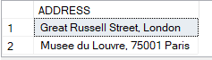

**--3.2. Show the directors of the museums and the names of the museums**

select e.NAME, e.MUSEUM_NAME

from EMPLOYEE e

where e.POSITION='Director'

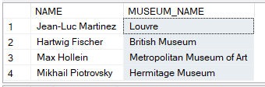

**--3.3. Show the ID and type of the items which count is bigger than 600 and price less than 10**

select i.ID, i.TYPE

from ITEM i

where i.COUNT>600

and i.PRICE<10

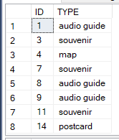

**--3.4. Show the type and museums which address is ending on London or York and aren't historic**

select m.NAME, m.TYPE

from MUSEUM m

where m.type!='art, historic'

and m.ADDRESS like '%London'

or m.ADDRESS like '% New York'



**--3.5. Show the id and the country of the exhibits which year is 2600, condition is bigger than 1 and the country doesn’t start with G**

select ex.ID, ex.COUNTRY

from EXHIBIT ex

where ex.year = 2600 and ex.CONDITION>1

and ex.COUNTRY not like 'G%'



**--3.6. Show the names of museums and types of items which at least 2 of them are with the same count and price, ordered by the names of the museums**

select distinct i1.MUSEUM_NAME, i1.TYPE

from ITEM i1, ITEM i2

where i1.COUNT=i2.COUNT

and i1.PRICE=i2.PRICE

order by 1,2

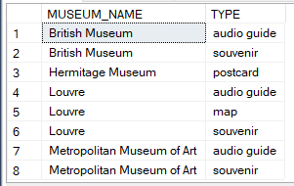

**--3.7. Show the name of the exhibitions, museums in which the name of exhibition is Russian art and the number of visitors is bigger than 500**

select distinct ex. NAME, m.Name

from MUSEUM m, VISITORS v, EXHIBITION ex

where ex.MUSEUM_NAME=m.NAME and m.NAME=v.MUSEUM_NAME

and ex.NAME='Russian art'

and v.VISITORS_COUNT>500



**--3.8. Show directors of the museums without audio guide but with the best condition of exhibits**

select em.NAME, em.MUSEUM_NAME

from EMPLOYEE em, EXHIBIT e

where em.position='Director' and e.MUSEUM_NAME=em.MUSEUM_NAME

and e.CONDITION=1

except

select em.Name, em.MUSEUM_NAME

from EMPLOYEE em, ITEM i

where i.MUSEUM_NAME=em.MUSEUM_NAME

and i.TYPE='audio guide'

order by 2



**--3.9. Show the directors of the museums with at least 2 exhibitions with the same exhibit count**

select em.salary, em.NAME

from MUSEUM m, EXHIBITION ex1, EXHIBITION ex2, EMPLOYEE em

where ex1.exhibit_count=ex2.exhibit_count

and ex1.NAME!=ex2.NAME

and ex1.MUSEUM_NAME=m.NAME and ex2.MUSEUM_NAME=m.NAME and m.NAME=em.MUSEUM_NAME and em.position='Director'

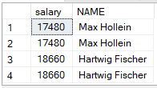

**--3.10.Show the websites of all museums in New York and all museums with the salary of employees = 8960**

select m.website

from MUSEUM m, EMPLOYEE em

where m.NAME=em.MUSEUM_NAME

and em.SALARY=8960

union

select m.website

from MUSEUM m

where m.ADDRESS like '%New York%'



**Тема 4: Примери с подзаявки**

**--4 Subqueries**

**--1 Извежда име на музей, година на основаване и адрес на музея, където е експонатът Мона Лиза на Леонардо Да Винчи**

SELECT M.NAME Museum, M.ESTABLISHED Established, M.ADDRESS Address

FROM MUSEUM M

WHERE NAME = (SELECT E.MUSEUM_NAME

FROM EXHIBIT E

WHERE E.NAME = '"Mona Lisa" by Leonardo da Vinci');

**--2 Извежда името, уебсайта и броя работници на музеите, датиращи преди Лувъра**

SELECT M.NAME Name, M.WEBSITE Website, M.EMPLOYEE Employee

FROM MUSEUM M

WHERE M.ESTABLISHED < ANY(SELECT E.YEAR

FROM EXHIBIT E

WHERE E.MUSEUM_NAME = 'Louvre');

**--3 Извежда цялата информация за изложбата, в която има експонат от 1300г.**

SELECT *

FROM EXHIBITION E

WHERE E.NAME = (SELECT EX.EXHIBITION_NAME

FROM EXHIBIT EX

WHERE EX.YEAR = 1300);

**--4 Извежда всичката информация за изложбата, която се намира в “Metropolitan Museum of Art”**

SELECT *

FROM EXHIBIT E

WHERE E.MUSEUM_NAME = (SELECT M.NAME

FROM MUSEUM M

WHERE M.NAME = 'Metropolitan Museum of Art');

**--5 Извежда име, уебсайт и брой работници на музей, където броят на работниците е по-голям от всички музеи с повече от 100 работници**

SELECT M.NAME Name, M.WEBSITE Website, M.EMPLOYEE Employee

FROM MUSEUM M

WHERE M.EMPLOYEE > ANY(SELECT MU.EMPLOYEE

FROM MUSEUM MU

WHERE MU.EMPLOYEE >= 100)

ORDER BY EMPLOYEE DESC

**Резултат от изпълнение на заявките:**

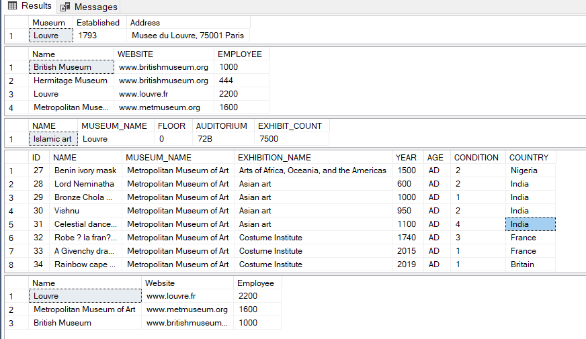

**Тема 5: Примери със съединения**

**--5.1. Show the names and conditions of the exhibits in the museums with most visitors**

select e.NAME, e.CONDITION

from VISITORS v

join MUSEUM m on m.NAME=v.MUSEUM_NAME

join EXHIBITION ex on m.NAME=ex.MUSEUM_NAME

join EXHIBIT e on ex.MUSEUM_NAME= e.MUSEUM_NAME

where v.VISITORS_COUNT>=ALL(select VISITORS_COUNT

from VISITORS)

order by 2

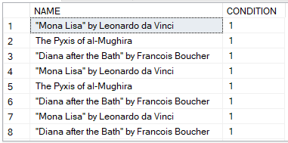

**--5.2. Show the name, address and type of the museum with no visitors or without any souvenirs**

select m.NAME, m.ADDRESS, m.TYPE

from MUSEUM m

left join (select v.VISITORS_COUNT, v.MUSEUM_NAME

from VISITORS v

union all

select i.COUNT, i.MUSEUM_NAME

from ITEM i

where i.TYPE='souvenir')wthout

on wthout.MUSEUM_NAME=m.NAME

where wthout.VISITORS_COUNT is null



**--5.3. Show the count of visitors if it is bigger than the number of audio guides in the museum**

select v.VISITORS_COUNT, v.MUSEUM_NAME, i.PRICE, i.COUNT

from VISITORS v

inner join item i

on v.VISITORS_COUNT>=i.COUNT

and i.MUSEUM_NAME=v.MUSEUM_NAME

and i.TYPE='audio guide'

order by 3, 4

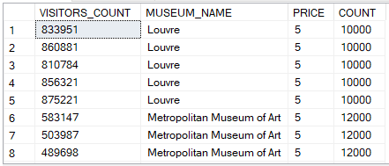

**--5.4. Show the name, website and type of the museums which is not historic are established before 1880, the count of exhibits is less than 10**

select distinct t1.NAME, t1.WEBSITE, t1.TYPE

from (select m.NAME, m.ESTABLISHED, m.WEBSITE, m.TYPE

from EXHIBITION ex cross join MUSEUM m

where ex.EXHIBIT_COUNT>=5000 and ex.MUSEUM_NAME=m.NAME

)t1

inner join(select m.ESTABLISHED

from MUSEUM m

where m.ESTABLISHED<=1880) t2

on t1.ESTABLISHED=t2.ESTABLISHED

where t1.TYPE ='art'

order by 1

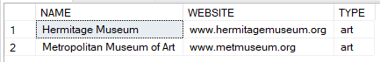

**--5.5. Show the age and condition which are the same in at least 2 of the exhibits**

select distinct e1.AGE, e1.CONDITION

from EXHIBIT e1

join EXHIBIT e2 on e1.AGE=e2.AGE

and e1.CONDITION=e2.CONDITION

and e1.ID!=e2.ID

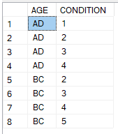

**Тема 6: Примери с групиране и агрегация:**

**--1 Извежда интернет страницата на музеите, посещавани от над половин милион души средно на ден**

select m.WEBSITE, AVG(v.VISITORS_COUNT) AvgVisitors

from VISITORS v

join MUSEUM m on m.NAME = v.MUSEUM_NAME

group by m.WEBSITE

having AVG(v.VISITORS_COUNT) > 500000

**--2 Извежда имената на музеите, които съхраняват експонати от преди Христа**

select m.NAME

from EXHIBIT e

join MUSEUM m on m.NAME = e.MUSEUM_NAME

where e.AGE = 'BC'

group by m.NAME

**--3 Извежда имената на музеите, които съхраняват поне 5 експоната от Средновековието**

select m.NAME

from EXHIBIT e

join MUSEUM m on m.NAME = e.MUSEUM_NAME

where e.YEAR > 395 and e.YEAR < 1453

group by m.NAME

having count(e.NAME) >= 5

**--4 Извежда броя и общата им цена на всички продукти и услуги, които посетител може да си купи от съответния музей**

select m.name, count(i.PRICE) as NumOfProducts, SUM(i.PRICE) as SumOfAllProducts

from ITEM i

join MUSEUM m on i.MUSEUM_NAME = m.NAME

group by m.NAME

**--5 Извежда държавите с над 5 експоната**

select e.COUNTRY

from EXHIBIT e

join MUSEUM m on m.NAME = e.MUSEUM_NAME

group by e.COUNTRY

having count(m.NAME) > 5

**--6 Извежда имената на изложбите, които са били посещавани общо от над 3 000 000 посетители**

select e.NAME

from EXHIBITION e join (select m.NAME

from MUSEUM m JOIN VISITORS v on m.NAME = MUSEUM_NAME

group by m.NAME

having SUM(v.VISITORS_COUNT) > 3000000) m

on m.NAME = e.MUSEUM_NAME

group by e.NAME

**--7 Извежда продуктите и услугите на музея, чиито служители взимат най-голяма средна заплата**

select i.TYPE, i.MUSEUM_NAME

from ITEM i join

(select e1.MUSEUM_NAME, AVG(e1.SALARY) avg_salary

from EMPLOYEE e1

group by e1.MUSEUM_NAME

) e on i.MUSEUM_NAME = e.MUSEUM_NAME

where e.avg_salary =

(select MAX (t.avg_salary)

from

( select m.NAME, AVG (e.SALARY) avg_salary

from MUSEUM m join EMPLOYEE e on m.NAME = e.MUSEUM_NAME

group by m.NAME

) t

)

**Резултат от изпълнение на заявките:**

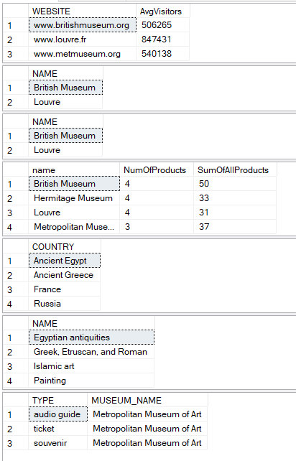

**Тема 8 Индекси:**

CREATE INDEX IDX_EXHIBIT

ON EXHIBIT (MUSEUM_NAME, EXHIBITION_NAME);

CREATE INDEX IDX_EMPLOYEE

ON EMPLOYEE (POSITION);

**Изгледи:**

**1. Create a view showing name, museum name and position of all directors, ordered by museum name.**

CREATE VIEW V_EMPLOYEE_PARTIAL_INFO

(NAME, MUSEUM, POSITION)

AS

SELECT E.NAME, E.MUSEUM_NAME AS MUSEUM, E.POSITION

FROM EMPLOYEE E

WHERE POSITION='Director'

ORDER BY MUSEUM;

**2. Create a view showing name, museum name,exhibition name, address of museum, floor, auditorium and condition of all exhibits, ordered by exhibit name.**

CREATE VIEW V_EXHIBIT_TRANSPORT_INFO

(NAME, MUSEUM, EXHIBITION, ADDRESS, FLOOR, AUDITORIUM, CONDITION)

AS

SELECT E.NAME AS EXHIBIT, M.NAME AS MUSEUM, EXH.NAME AS EXHIBITION, M.ADDRESS, EXH.FLOOR, EXH.AUDITORIUM, E.CONDITION

FROM MUSEUM M JOIN EXHIBITION EXH on

M.NAME=EXH.MUSEUM_NAME JOIN

EXHIBIT E ON EXH.NAME=E.EXHIBITION_NAME

ORDER BY E.NAME;

**3. Create a view showing name, price of tickets, total visitors and total income from tickets for all museums.**

CREATE VIEW V_TICKET_INCOME

(NAME, TICKET_PRICE, VISITORS, TOTAL)

AS

SELECT V.MUSEUM_NAME AS MUSEUM,I.PRICE, SUM(V.VISITORS_COUNT) AS VISITORS,SUM(V.VISITORS_COUNT)*I.PRICE AS TOTAL

FROM ITEM I JOIN VISITORS V ON

I.MUSEUM_NAME = V.MUSEUM_NAME AND I.TYPE = 'ticket'

GROUP BY V.MUSEUM_NAME, I.PRICE;

**4. Create a view showing name, sum of the number of exhibits of all exhibitions and number of employees for all museums**

CREATE VIEW V_MUSEUM_STATISTIC

(NAME, EXHIBIT_COUNT, EMPLOYEE_COUNT)

AS

SELECT M.NAME,SUM(E.EXHIBIT_COUNT) AS EXHIBIT_COUNT,M.EMPLOYEE AS EMPLOYEE_COUNT

FROM MUSEUM M JOIN EXHIBITION E ON

M.NAME = E.MUSEUM_NAME

GROUP BY M.NAME, M.EMPLOYEE;

**5. Create a view showing name of museum, address, max salary and position for all positions in every museum in descending order**

CREATE VIEW V_MAX_PAID_EMPLOYEE

(NAME, ADDRESS, SALARY, POSITION)

AS

SELECT M.NAME, M.ADDRESS, MAX(E.SALARY) AS MAX_SALORY,POSITION

FROM MUSEUM M JOIN EMPLOYEE E ON

M.NAME = E.MUSEUM_NAME

GROUP BY M.NAME, M.ADDRESS,POSITION

ORDER BY MAX(SALARY) DESC;



**Тема 9 Тригъри:**

**--Уголемяване на буквите за по-добра четимост след въвеждане в таблицата**

if exists (select 1

from sys.objects

where type = 'TR'

and name = 'exhibit_up_name')

drop trigger exhibit_up_name;

GO

CREATE TRIGGER exhibit_up_name ON exhibit AFTER INSERT AS

BEGIN

UPDATE EXHIBIT SET NAME = UPPER(NAME);

UPDATE EXHIBIT SET MUSEUM_NAME = UPPER(MUSEUM_NAME);

UPDATE EXHIBIT SET EXHIBITION_NAME = UPPER(EXHIBITION_NAME);

UPDATE EXHIBIT SET COUNTRY = UPPER(COUNTRY);

END

**--Показва имената на изтритите експонати и музеите, в които са били съхранявани**

if exists (select 1

from sys.objects

where type = 'TR'

and name = 'delete_exhibit_name')

drop trigger delete_exhibit_name;

GO

CREATE TRIGGER delete_exhibit_name ON EXHIBIT FOR DELETE AS

BEGIN

select NAME, MUSEUM_NAME

from deleted;

END;

**--Проверка на телефонните номера на служителите дали са валидни при промяна**

if exists (select 1

from sys.objects

where type = 'TR'

and name = 'check_data_employee')

drop trigger check_data_employee;

GO

CREATE TRIGGER check_data_employee ON EMPLOYEE FOR UPDATE AS

BEGIN

declare @new_telnumber as CHAR(10);

select @new_telnumber = TELEPHONE from inserted;

IF ( PATINDEX ('%[^0-9]%', @new_telnumber) > 0 )

BEGIN

PRINT 'Incorrect telephone number!';

Rollback;

END

END;

**--Проверка на данните при експонатите дали са валидни при промяна**

if exists (select 1

from sys.objects

where type = 'TR'

and name = 'check_data')

drop trigger check_data;

GO

CREATE TRIGGER check_data ON EXHIBIT FOR UPDATE AS

BEGIN

declare @new_condition as INT;

select @new_condition = CONDITION from inserted;

declare @new_age as char(2);

select @new_age = AGE from inserted;

declare @new_year as INT;

select @new_year = YEAR from inserted;

if (@new_condition < 1 or @new_condition > 5)

begin

print 'New condition is out of range (1-5)!';

Rollback;

end;

if (@new_age != 'AD' and @new_age != 'BC')

begin

print 'New age is incorrect! There are two correct values: AD or BC';

Rollback;

end;

if (@new_year > 2022 and @new_age = 'AD')

begin

print 'New year is incorrect!';

Rollback;

end;

END;